**CIS 375 – Fall 2019 Term Project - BRAINS**



Use Case Specification Document

**1**

**Answers**

**Version No. 1.1.0**

**Project Document Revision History**

|  |  |  |  |
| --- | --- | --- | --- |
| **Version Number** | **Date** | **Revision Author** | **Description of Revision** |
| 1.0.2 | 10/27/2019 | Zakariya Ahmed | Creation of document |
| 1.03 | 10/30/2019 | Kevin Longworth | Updated flows |
| 1.1.0 | 10/30/2019 | Muaz Alhaidar | Updated written paths to match new flows of diagram |

|  |
| --- |
| **Table of Contents** |

1. Introduction 4

2. Use Case Information 4

2.1 Actors 4

2.2 Use Case Interaction 4

3. Trigger 4

4. Pre-condition(s) 5

4.1 User has log in, Use Case 2 5

4.2 If user is sending STENER, then current STENER is done 5

4.3 If user is receiving STENER, then no other prior condition is needed. 5

5. Post-condition(s) 5

5.1 STENER is being sent to oversight 5

5.2 STENER is being received to any departments 5

6. Use Case Swimlane (Activity) Diagram 5

7. Main/Basic Flow(s) of Events (Happy Path) 6

7.1 STENER is successfully submitted 6

8. Alternate/Exception Flow of Events 6

8.1 Department sends an incomplete STENER 6

9. Assumptions/Business Rules including Non-Functional Requirements 6

10. Use Case Specification Review and Signoff 6

# Introduction

This document captures detailed functional and non-functional BUSINESS requirements. Technical or application IT requirements should not be detailed here. A separate Use Case Summary document ties ALL the individual use cases together. First create the Use Case Summary document using application decomposition. Then increase the detail by creating the individual use case specifications – be careful not to create too many or not create enough use cases.

Write a single paragraph describing the purpose of the specific use case in the Introduction.

The purpose of this use case is to deal with the answering/questioning of STENERS.

# Use Case Information

## Actors

An actor is someone or something (e.g. application system) outside the system or business that interacts with the application. For every Use Case, there must be at least one Main Actor and zero or more Secondary Actors. Actors should be a person, system, or time.

|  |  |  |
| --- | --- | --- |
| Actor Name | Role | Description |
| Database | Secondary | The middleman between Departments and the Oversight team |
| Departments | Main | They send/receive STENERS through the database |

## Use Case Interaction

How does this use case relate to other uses cases? List predecessor and successor use cases

.

This relates to other use cases because this is the process of sending/receiving STENERS: Use Case 2 (Login and Account Creation) is the authorization part of receiving/sending STENERS and Use Case 3 (Question Maintenance) is the creation of STENERS, come before Use Case 1. Use Case 6 (STENER Management) come after, and are the process of converting STENERS that are submitted, and getting information from them.

# Trigger

What causes the use case to initiate?

When a Department/Oversight team receive/send STENERS.

# Pre-condition(s)

What use cases or other pre-conditions must be met before use can initiate?

## User has log in, Use Case 2

## If user is sending STENER, then current STENER is done

## If user is receiving STENER, then no other prior condition is needed.

# Post-condition(s)

What are ALL the possible output states upon completion of the use case flows?

## STENER is being sent to oversight

## STENER is being received to any departments

# Use Case Swimlane (Activity) Diagram

Draw diagram(s) that cover ALL main and alternate flows.

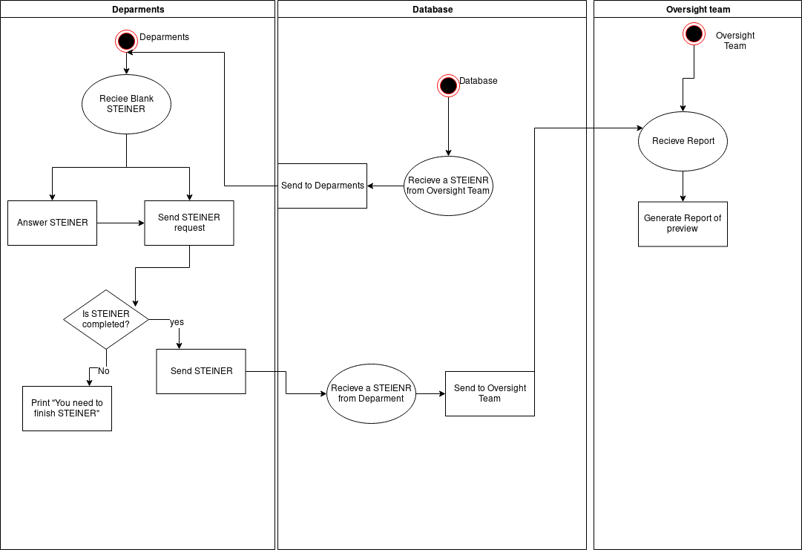

# Main/Basic Flow(s) of Events (Happy Path)

For each main flow (usually ONE flow) write the list of steps that occur – describe WHAT occurs not HOW to do it!

## STENER is successfully submitted

* Department receives a blank STENER
* department fills out STENER
* department send STENER
* database receives the STENER
* oversight team receives the STENER

# Alternate/Exception Flow of Events

For each alternative flow (can be zero or more) write the list of steps that occur – describe WHAT occurs not HOW to do it!

## Department sends an incomplete STENER

* Department fills out STENER partially
* Sends STENER
* System states “ STENER is incomplete” and the user must finish filling out the STENER

# Assumptions/Business Rules including Non-Functional Requirements

Be sure to number the assumption/business rules to allow easy reference to them. Business rules will be where non-functional requirements are recorded – have a way to specifically identify non-functional requirements.

# Use Case Specification Review and Signoff

|  |  |  |  |
| --- | --- | --- | --- |
| Review and Signoff of the Use Case Specification | | | |
| Name | Project Team Role | Signature | Date |
| Ahmed, Zakariya | Senior Tech Lead/SPMP manager | Z.A. | 10/30/19 |
| Alhaidar, Muaz | Developer | M.A. | 10/30/19 |
| Longworth, Kevin | Developer | K.L. | 10/30/19 |
| Labut, Cameron | Developer | C.L. | 10/30/19 |
| Majzoub, Mostafa El | Developer | M.M | 10/30/19 |